|  |
| --- |
| **OTAGO Polytechnice Auckland International campus** |
| Assignment -1 |
| (Individual) |
| Submission Date: 17th November 2019 |
| **Prepared By:** |
| **Vimitaben Vaidya** |

|  |
| --- |
|  |

**IX 713001 Computer Human Interaction Design**

# Summary

This assignment shows the different concepts of computer human interaction. The purpose of this assignment is to understand the conceptualize interaction and how conceptual model is helping to understand the requirements of system and give the purpose to create the system. It also includes cognitive process and their importance to interaction design of system with their different models and frameworks associated with interaction design.

User interface design of AR TRY – ON android application which is based on augmented reality has greater impact of conceptual model and universal design principle on developer. It helps designer to make it design easy, simple and user friendly. In other words, it defines the what the system is about and how user/customer can easily access this system.

# Table of Contents

Contents

Summary 2

1 Table of Contents 3

2 List of figures 3

3 Introduction 4

4 Conceptual Modelling 4

4.1 Conceptual model relation with AR TRY-ON app 4

4.2 Universal Design Principal 4

4.3 Human Limitation 8

4.4 Human cognitive processes changes in stimuli can affect your design 8

5 Discussion and Design 9

5.1 Activity Diagram 10

5.2 Use Case Diagram 11

5.3 Prototype 12

6 Conclusion 16

Future Work 16

7 Reference List 17

# List of figures

Figure 1 Universal design principle - constraints 6

Figure 2 Universal design principle - Mappings 7

Figure 3 Universal design principle - visibility 7

Figure 4 Universal design principle - feedback 8

Figure 5 Universal design principle - consistency 8

Figure 6 The 5-sense applied in HCI [2] 9

Figure 7 AR - market value in e-commerce [1] 10

Figure 8 Activity diagram of AR TRY-ON application 11

Figure 9 Use Case diagram 12

Figure 10 List of products 13

Figure 11 Different model of item 14

Figure 12 Brief description of product 15

Figure 13 Brief description of Ring item 16

Figure 14 Try item on self 17

# Introduction

The goal of the project is to create an AR TRY-ON Android App for object visualisation such as watch, ring, bracelets that gives our potential customers new unique user experience and allow them to look at the item more precisely and in more detail.

Ecommerce marketing strategies often rely on expensive catalogues with impeccable photography of watch, rings, bracelets, necklaces, earrings and such. However, the customers would feel much better if they knew this item design suited them. They could look at the product in three dimensions, from different sizes, and scale.

Using augmented reality allows us to bring virtual objects in the real world. In this way, an augmented reality app for smartphone owners can turn all items of catalogues into 3D animated models. In jewellery or watch it’s all about presentation and showcases. People only need to point their mobile devices onto the showcases.

# Conceptual Modelling

Conceptual model is a model where designer develop high-level design for how the product will work and fit together (Brajdic, 2019). It is made up of different elements that shape the organisation of the system and is ultimately represented in the interface that the customer interacts with.

## Conceptual model relation with AR TRY-ON app

Conceptual Models is about what a device is for and how it works. In other words, when the conceptual model the user builds is an accurate reflection of how the device works, they will be able to predict correctly the effects of their actions. they can use the device successfully without training, or experimentation.

In the AR TRY-ON application user can experience on self with any items by clicking on button. Which directly open device camera and user can try different watch models on their hand and try other jewellery item also.

## Universal Design Principal

There are many components about any device that determine what conceptual model of that device the user builds. They are affordances, constraints, visibility, feedback, consistency and mappings. Together, they determine whether a user develops a good, useful conceptual model, or a bad, obstructive conceptual model.

Following are universal design principal affect AR TRY-ON application

* Affordances:

Affordance is a properties or characteristics of a system that indicate “what it is for”. In other words, it gives an idea to the users on how to use the application or products.

Here, affordance is of AR TRY-ON application is gives idea to the user/customer if they want to buy any products with real life virtual experience of item on themselves.

* Constraints:

Constraint restrict the possible actions that can be performed. Every object has constraints or limitations, properties of its structure that make some actions impossible. In other words, constraints can be designed in for the express purpose of reducing errors or difficulties when working with a device.

Constraints for this application is, user must need to click on button if they want to explore detail information or they want to try item on self.

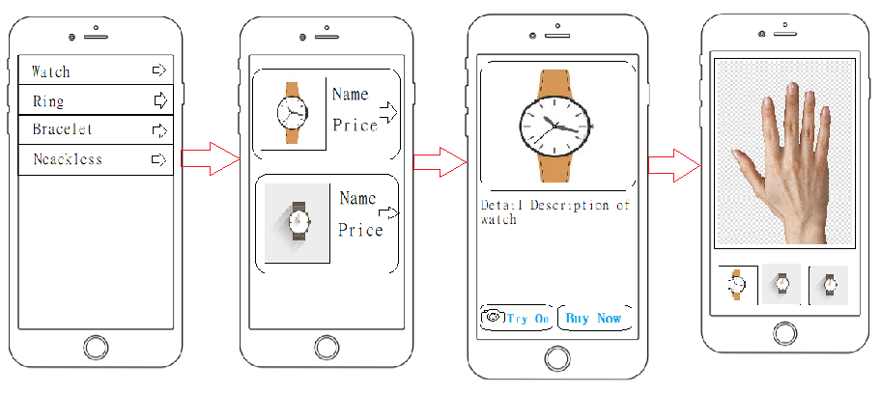

Figure 1 Universal design principle - constraints

* Mappings:

Mapping made easy for user to interact with core functionality of product. Customer friendly behaviour which made easy by applying different colour code of control, placing relevant icon, and position of control.

Here, TRY-ON button is place exactly near by Buy now button which gives idea to the user. Also, camera icon on Try – On button gives idea to the user.



Figure 2 Universal design principle - Mappings

* Visibility:

The controls of a system must be visible, “can be seen” and they must convey the correct message as to how to use them, and what the result will be “can tell how they work”.

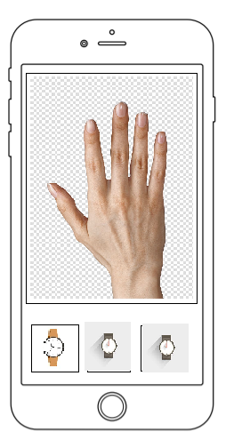

**Visibility –** different models are visible for user for try.

Figure 3 Universal design principle - visibility

* Feedback:

Sending information back to the user about what has been done includes sound, highlighting, animation and combination of any of those.

Here, in AR TRY-ON application which is based on augmented reality where user can feel live experience as a feedback where they can make their decision about, they want to buy it or not. It acknowledge to them how it looks after trying on themselves.

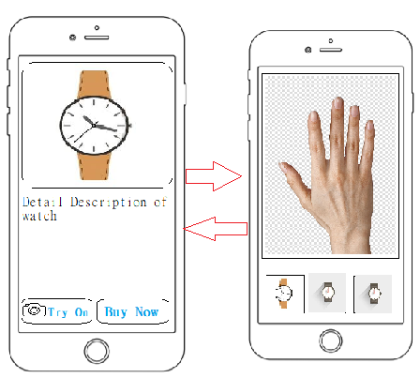

Figure 4 Universal design principle - feedback

* Consistency

Consistency decide that design interfaces to have similar operations and use similar elements for similar tasks.

Here, arrow indicates that user need to click for further detail.

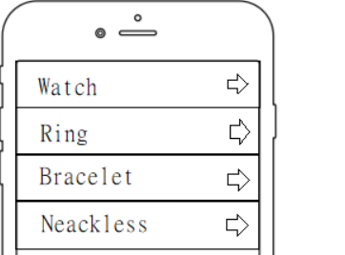

**Consistency**



Figure 5 Universal design principle - consistency

## Human Limitation

* Physical inability
* All humans have limitations in their physical capabilities. Some are immediately visible, others are not.
* When you design from an HCI (Human Computer Interaction) perspective, you begin to realise that limitations in disabilities are very often discussed. One of the most promising areas of application is the application of HCI to support and improve the physical capacity of human beings (Considering Human Limitations, Disabilities, and Design (HCI), 2017).
* As consider this limitation in AR TRY-ON application, where humans are not able to use this system due to physical disability.
* Misjudgement
* Sometimes customers are mis-guide to buy online product or item. They may not exactly feel perfect in terms of colours or size.
* In AR TRY-ON application is based on virtual environment which may differ from real experience of wear watch or jewellery than try on imaginary using application.
* Rely on tools to complete tasks thus causing dependency
* Technology and tools relay to humans. In other words, their behaviour has been affected by human technical behaviour and cognitive functions (Capistrano, Fernandez, 2017).
* People might rely on AR TRY-ON application due to their technological dependent behaviour; they are not visit physical shop or showroom for buying watch, and jewellery.

## Human cognitive processes changes in stimuli can affect your design

* There are many factors of human cognitive process which affects design. These are,

Figure 6 The 5-sense applied in HCI [2]

* Eye and sound are commonly accepted as the two important critical senses for designer to invent design in the age of visual interfaces (Mair, 2018).
* The Eye
* Even though most designers would not consider themselves biologists, it is important to understand the elements of the human brain in order to understand the consequences of our designs.
* Therefore, to avoid confusion, developer need to design icons or user interface which user can easily understand by relating to the action in the real world.
* Touch
* Touch is one of the most components while designing user interface.
* By applying different styles in elements which make action clear and user friendly so that user can deal with application fluently.

# Discussion and Design

* Augmented Reality is a rapidly growing technology with many future market possibilities. Augmented reality is most often compared to VR (virtual reality), however, it is technically two different technologies.
* Augmented reality is creating an imaginary layer on top of reality. For instance, it can scan a package's bar code with your smartphone or laptop and make the product appear in front of your eyes like a hologram. In other words, something intangible is introduced into the real world.
* Augmented Reality increase the e-commerce market in real world.
* According to the BRP 2018 Digital Commerce Benchmarking Survey, in three years 32% of retailers plan to implement Augmented Reality and 48% of retailers will more likely shop in a store using AR (The Definitive Guide to Augmented Reality in Retail - 28 Examples, 2019).

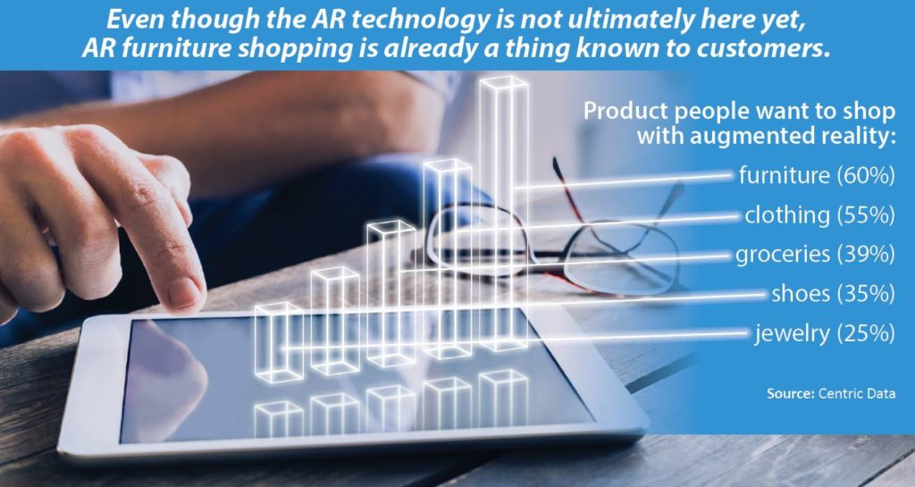

Figure 7 AR - market value in e-commerce [1]

## Activity Diagram

* Activity diagram focus on condition of and the sequence in which it happens (Unified Modeling Language (UML): Activity Diagrams, 2018).
* Below activity diagram defines the flow of AR TRY-ON application how it works and how user can interact with this application.
* Each activity defines the process of application. Here, when user click on item list it displays a various range of item model where they can try those products virtually on self or else, they also know the detail description of item, at the end user can decide for checkout.

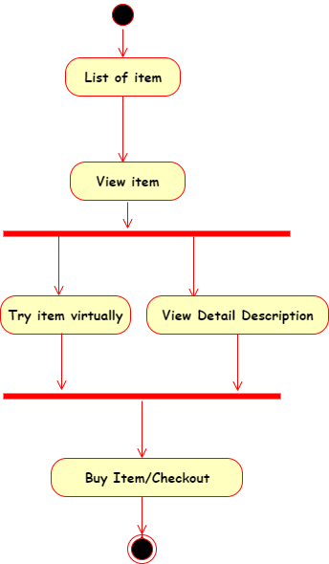

Figure 8 Activity diagram of AR TRY-ON application

## Use Case Diagram

* Use case diagrams specify how the system interacts with actors without worrying about the details of how that functionality is implemented (Use Case Diagram, (n.d.)).
* Below use case diagram model defines the behaviour of system and core functionality of AR TRY-ON application using actors and use cases.
* Where, each use cases are a set of actions, services, and functions that the system needs to perform. Here, use cases are Item List, View Items, Try item, Detail Description and Checkout.
* In this diagram, a "system" is something being developed or operated, such as an application on the top left corner “AR TRY-ON” define the system name.
* The "actors" are people or entities operating under defined roles within the system. For this application actors are web customer which could be a register user or new user, admin and payment service.

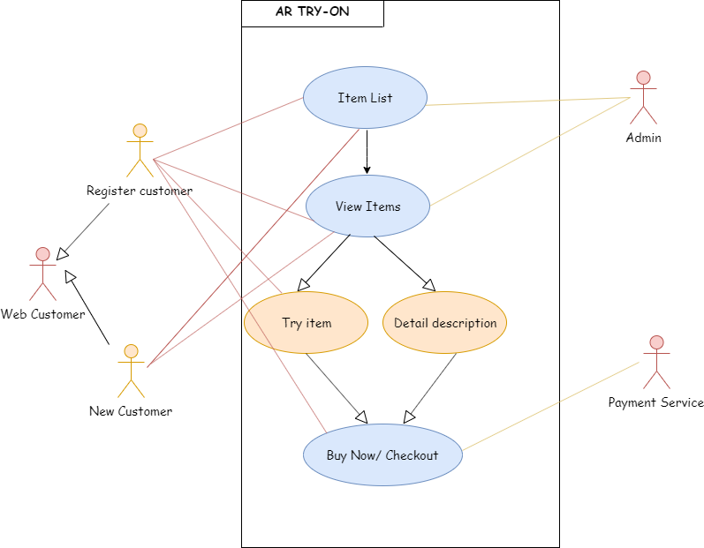

Figure 9 Use Case diagram

## Prototype

* Following are the prototype of AR TRY-ON application which describe a detail description and visualization of final product.
  + Below image describe the list of different items where user can explore it and buy it.

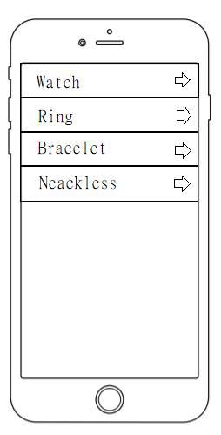

Figure 10 List of products

* Next, page of application gives the various watch models once customer click on watch item list. It shows with product name and their price. It also direct user to another page if user want to know about brief.

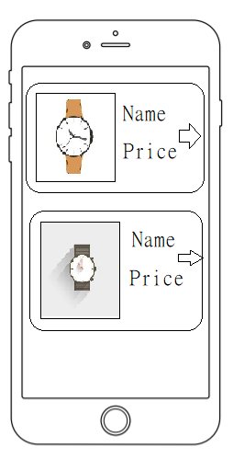

Figure 11 Different model of item

* Once user click on product, they know about the detail description of item. There have been also buttons, which give options to user if they want to buy it or else they want to try on or not.

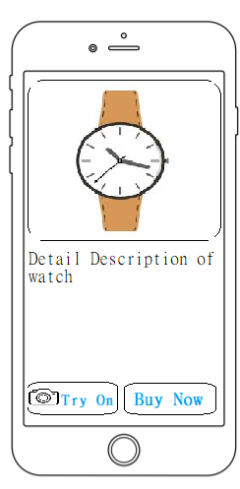

Figure 12 Brief description of product

* Below sketch shows when user click on ring item from list, where user can get idea about how it looks like on their hand by clinking on Try-On button. Else they want to buy it this product by click on Buy now button.

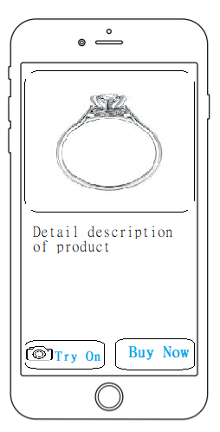

Figure 13 Brief description of Ring item

* Following both prototypes introduce the augmented reality effect, where customer feel real life experience of that product without visit physical shop. Below image gives the idea about how product will look like on them on self by clicking on Try-On button.

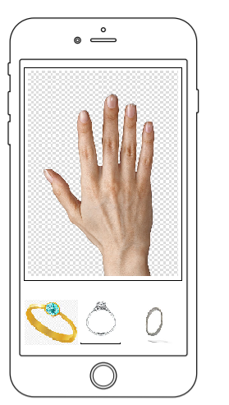

Figure 14 Try item on self

# Conclusion

Overall, AR technology holds a huge impact on e-commerce world. AR TRY -ON application fulfilled this new trend which affect the way consumers choose outlets, pick products and services, and shop. It is vital to the future of retailing to know what is different and what is similar in digital and offline worlds and the effect of new technologies on both. In addition, retailers need to adopt these new and emerging innovations to strengthen their consumers ' loyalty, while also promoting their lives. In a nutshell, the presence of conceptual model is hoped acts as guideline to help developer for creating mobile AR for enjoyable virtual shopping experience.

# Future Work

The Implementation of AR TRY-ON application will develop to support certain enhanced features and functionality as a further development.

# Reference List

Brajdic, A. (2019, June 27). Understanding mental and conceptual models in product design. Retrieved from <https://uxdesign.cc/understanding-mental-and-conceptual-models-in-product-design-7d69de3cae26>.

Capistrano, J., & Fernandez, R. (2017, November 6). Are We Too Dependent on Technology? Retrieved from <https://xenlife.com.au/are-we-being-too-dependent-on-technology/>.

Considering Human Limitations, Disabilities, and Design (HCI). (2017, August 22). Retrieved from <https://www.w3computing.com/systemsanalysis/considering-human-limitations-disabilities-design/>.

Mair, A. (2018, January 23). Cognition and Perception in HCI. Retrieved from <https://medium.com/@avimair/cognition-and-perception-in-hci-e134e3b4401f>.

The Definitive Guide to Augmented Reality in Retail - 28 Examples. (2019, August 23). Retrieved from <https://www.marxentlabs.com/ar-in-retail-top-augmented-reality-retail-apps-guide/>.

Unified Modeling Language (UML): Activity Diagrams. (2018, February 13). Retrieved from <https://www.geeksforgeeks.org/unified-modeling-language-uml-activity-diagrams/>.

Use Case Diagram. (n.d.). Retrieved from <https://www.smartdraw.com/use-case-diagram/>.

**Image reference**

1. Bell, R. (2018, June 13). The Reality Behind Augmented Reality. Retrieved from <https://retailernowmag.com/the-reality-behind-augmented-reality/>.
2. Mair, A. (2018, January 23). Cognition and Perception in HCI. Retrieved from <https://medium.com/@avimair/cognition-and-perception-in-hci-e134e3b4401f>.